| **Name : Yash Sarang** | **Class/Roll No. : 47** | **Grade :** |
| --- | --- | --- |

**Title of Experiment :** Mini Project on UXD

**Objective of Experiment :** The objective of this experiment is to design a wireframe for a user-friendly and efficient process on awebsite. The wireframe will serve as a visual representation of the interface, allowing us to identify potential usability issues and streamline the banking experience.

**Outcome of Experiment :**  Created a UXD for the Pharmacy Website

**Problem Statement :** Create A UXD for Pharmacy Website

## **Persona Design:**

### Persona: Sarah Thompson - Chronic Pain Patient

* Background:
  + Age: 45
  + Occupation: Office Manager
  + Medical Condition: Chronic back pain
  + Experience with Online Shopping: Moderate
* Goals and Needs:
  + Conveniently order prescription medications online for chronic pain management.
  + Receive timely deliveries to maintain medication adherence.
  + Access accurate information about the prescribed medications and their usage.
* Challenges:
  + Navigating the online platform to find specific medications.
  + Ensuring the security and confidentiality of personal and medical information.
  + Understanding potential interactions or side effects of prescribed medications.

**Persona Visualised: Moe Lester**

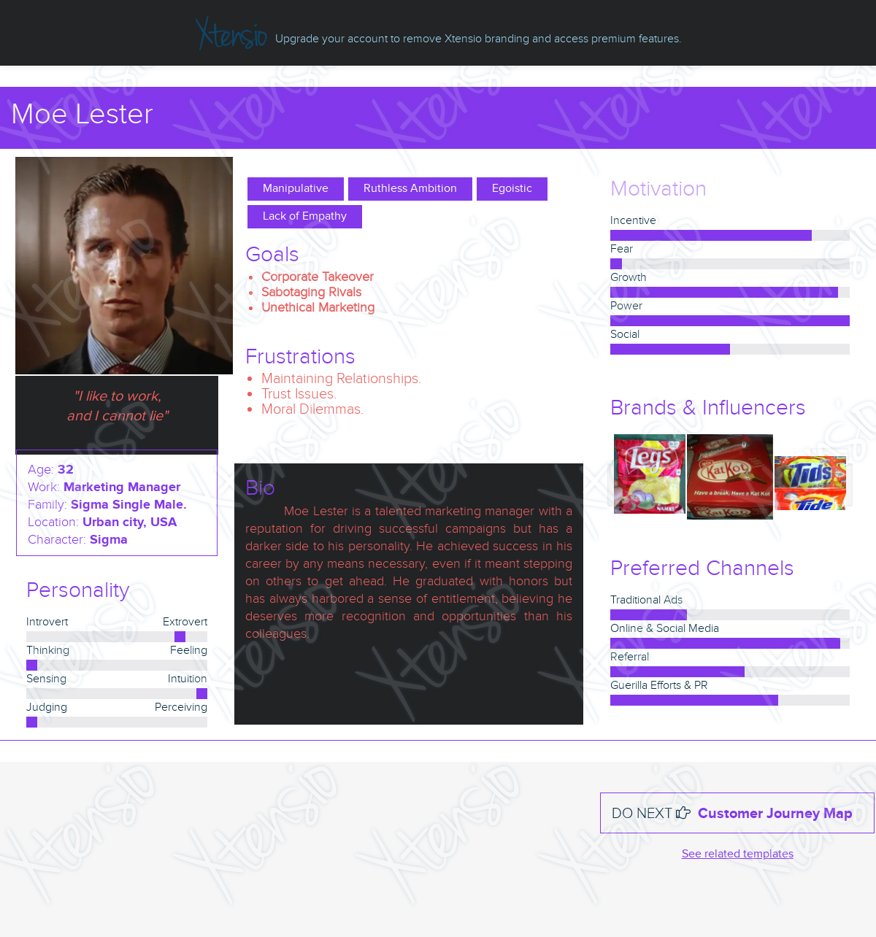

## **Problem Object Model:**

A problem object model would include entities like "User," "Medication," "Order," "Prescription," "Inventory," "Doctor," and "Pharmacist," with appropriate relationships and attributes to represent their interactions and properties.

However, creating a complete problem object model or entity-relationship diagram requires a deeper understanding of the specific system's requirements, constraints, and functionalities. Feel free to ask for more details or specific components for the object model or diagram

## 

## **ER Diagram**

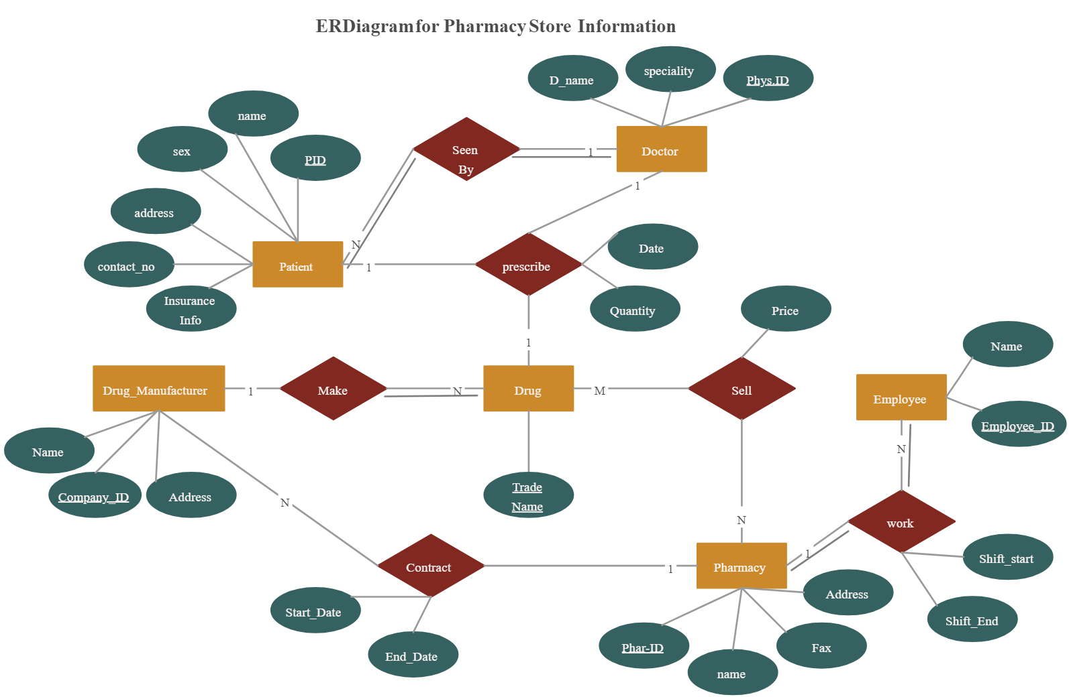

**Final UXD:**





